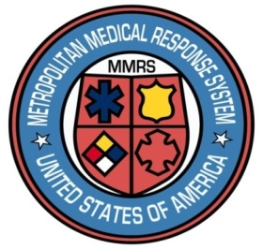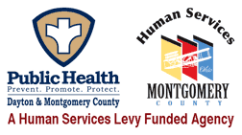

**Dayton MMRS Public Health - GMVEMSC**

**Dayton & Montgomery County**

**COVID-19 Bulletin 15**

**EMS Operations During Surge**

We are not only still in the midst of a pandemic; we are in the midst of an unprecedented surge. The number of COVID-19 patients in our region’s hospitals is higher than at any time in the pandemic. Other areas of the state have experienced even higher loads.

In addition to the patient surge, many organizations, including hospitals, public safety agencies, and others are dealing with record numbers of employees who are off in isolation or quarantine. See the separate “Regional COVID-19 Exposure Flowchart” for guidance on the new recommendations.

It is crucial that we continue to protect personnel, including protecting ourselves from each other. People asymptomatic or pre-symptomatic can spread COVID.

EMS is unique. We give care in a million different settings, many of which present hazards. One of those hazardous settings is the patient compartment of our ambulances and helicopters. Infectious disease risks are different in confined spaces.

There are effective protections.

* **Vaccination** continues to be our best protection, and getting a booster is very important! No vaccine lasts forever – you get a tetanus shot every few years, and a flu shot every year.  The latest data shows that vaccine effectiveness against infection for two doses of an mRNA vaccine is 35%. After a COVID-19 vaccine booster, it goes up to 75% almost immediately.  Even if you get COVID, vaccination decreases your risk of severe disease, hospitalization, and death. Individuals five and older should get vaccinated, and everyone 16 and older should get boosted as soon as they are eligible. Vaccination is the best way to protect yourself and reduce the impact of COVID-19 on families, workplace, and communities.
* **PPE:** Don’t forget to protect yourself in stations, vehicles and elsewhere. Wear the best mask you can. Wear a high-quality, well-fitting mask (in order, most effective to least):
  + N-95 or KN-95 masks. KN-95s are no longer in short supply, are recommended for the general public, and do not require fit-testing.
  + Next best would be a surgical or isolation mask **underneath** a three-ply cloth mask
  + A surgical or isolation mask tied to reduce gaps
  + A simple cloth mask provides the least amount of protection
* **Patient Care PPE**
* Place a mask on every patient, regardless of patient complaint. Use an isolation mask or an oxygen mask.
* Public safety personnel should wear at least an isolation (aka, surgical) mask for all patient contact. Eye protection and gloves
* Wear a PAPR or fit-tested N95 mask for higher risk situations, including all patient care in confined spaces such as the back of an ambulance, and whenever performing aerosol-generating procedures (AGPs).
  + AGPs include nebulizers, CPAP, intubation, and high-flow O2 by NRB.
* Use gowns, coveralls (e.g., Tyvek suits), eye protection, and of course gloves as appropriate.

**Patient Care Considerations**

* When available, use the patient’s metered dose inhaler (MDI) with a spacer instead of a nebulizer.  Bring all such equipment to the hospital with the patient.
* When feasible, perform AGPs such as CPR, CPAP, nebulizers, and intubation in an open-air environment, or with vehicle windows open while in transit.
* **Remove all aerosolizing devices from the patient just before entering the emergency department.**  Doing so helps prevent spreading aerosolized viral particles throughout the ED.
* During transport, vehicle ventilation in both compartments should be on non-recirculated mode to maximize air changes that reduce potentially infectious particles in the vehicle.
* If the vehicle has a rear exhaust fan, use it to draw air away from the cab, toward the patient-care area, and out the back end of the vehicle.