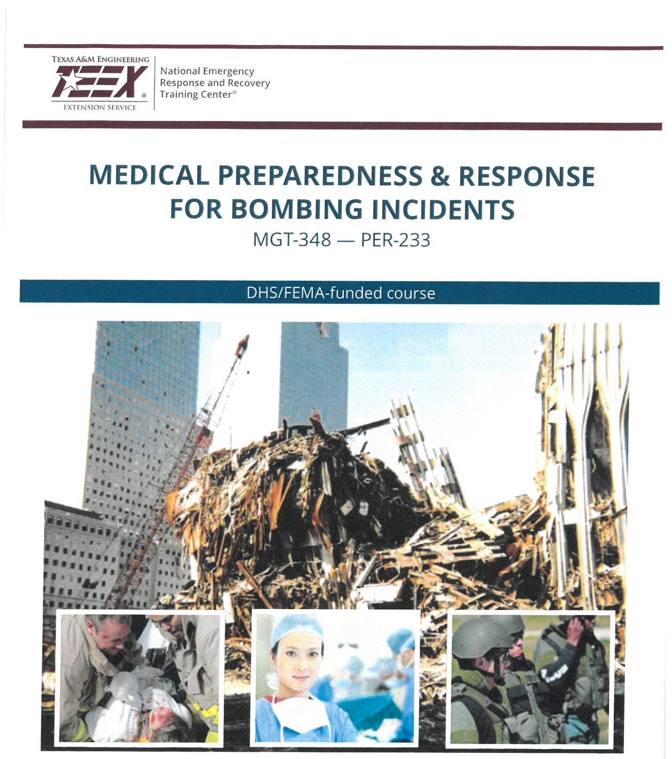
April 9&10, 2022 - 8:00am-5:00pm
THIS IS A WEEKEND CLASS

FCEM&HS

5300 Strawberry Farms Blvd., Columbus, OH 43230
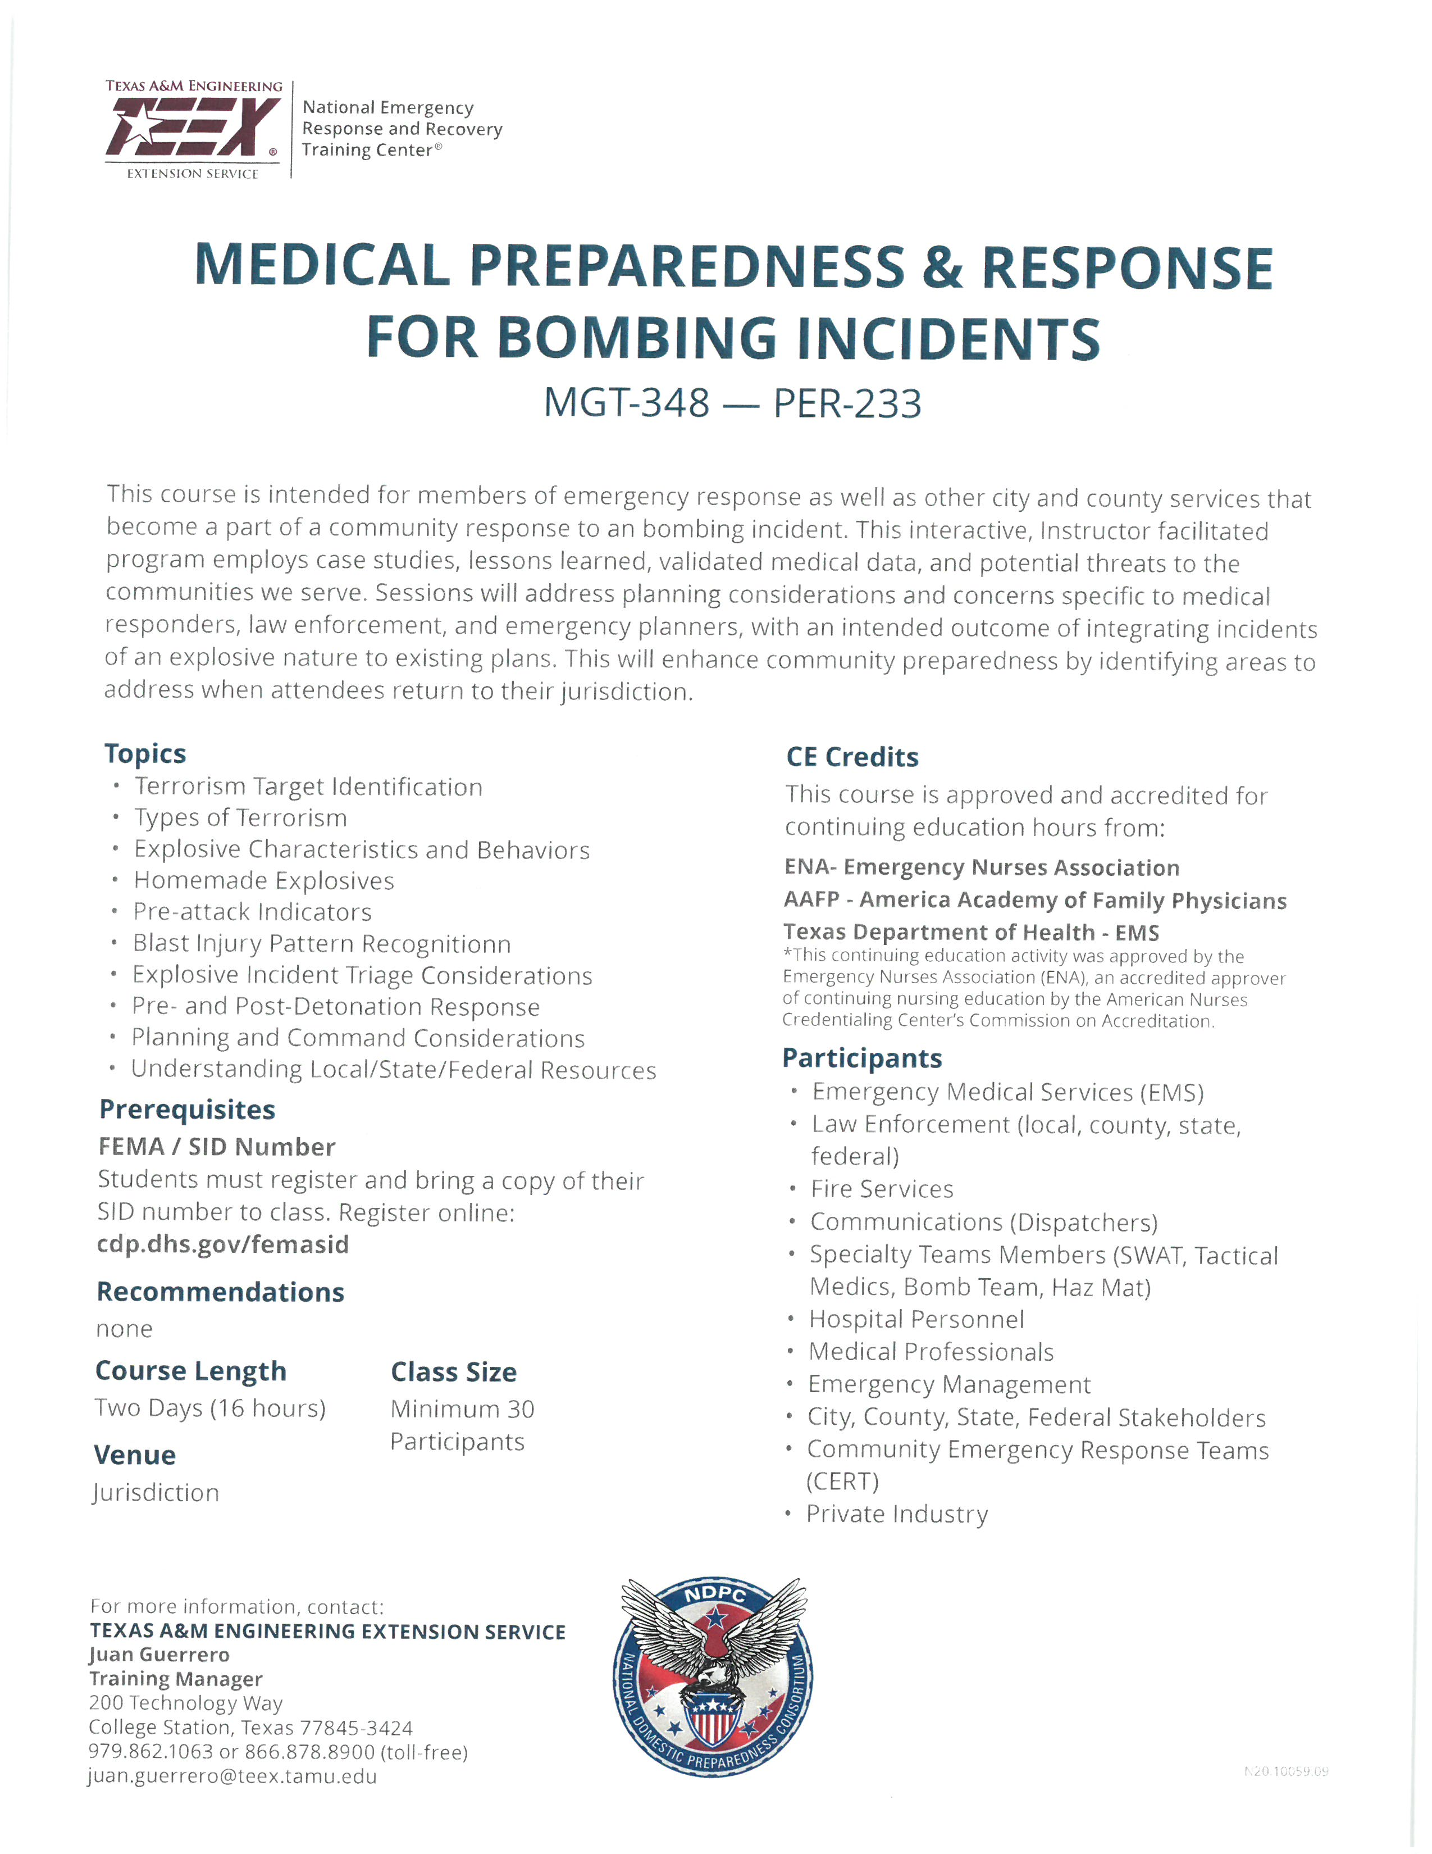
IMPORTANT REGISTRATION INFORMATION
Please use the paper registration form below.
Once you register with FCEM&HS and receive your approval by email, you will then be given information on how to register for the class on the TEEX website.
Medical Preparedness and Response for Bombing Incidents
MGT-348

April 9 & 10, 2022 – THIS IS A WEEKEND CLASS
8:00am-5:00pm

Registration Form

Name:

Organization:

Title:

Address:

City: Zip:

Phone: Email:

FEMA SID#:

Location of training:

FCEM&HS

5300 Strawberry Farms Blvd.

Columbus, OH 43230
Completed forms can be emailed to pktickle@franklincountyohio.gov

To retrieve your FEMA SID# or to create one, please use this link: https://cdp.dhs.gov/femasid/

