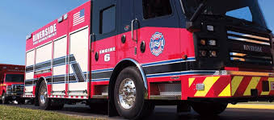  - ACLS Refresher  July 28, 2023  Riverside Fire is offering an ACLS Refresher  Refresher will be held at the Riverside City Building located at 5200 Springfield Street with class beginning at 9 AM. Light refreshments and coffee will be provided in the morning. All students must have a valid ACLS card and must complete the online pre-test. You must bring confirmation of a completed pre-test to class.  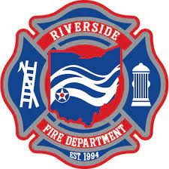 | Register by July 25!  ____  15 seats available!  ____  Location: 5200 Springfield Street, Riverside, OH, 45431  ____  Cost of the class is $10 paid to the Riverside Fire Department.  ____  Class Time: 0900-1300  For more information contact:  Isaac Hivner at ihivner  @riversideoh.gov  or:  Paula Balcom at  pabalcom  @premierhealth.com

