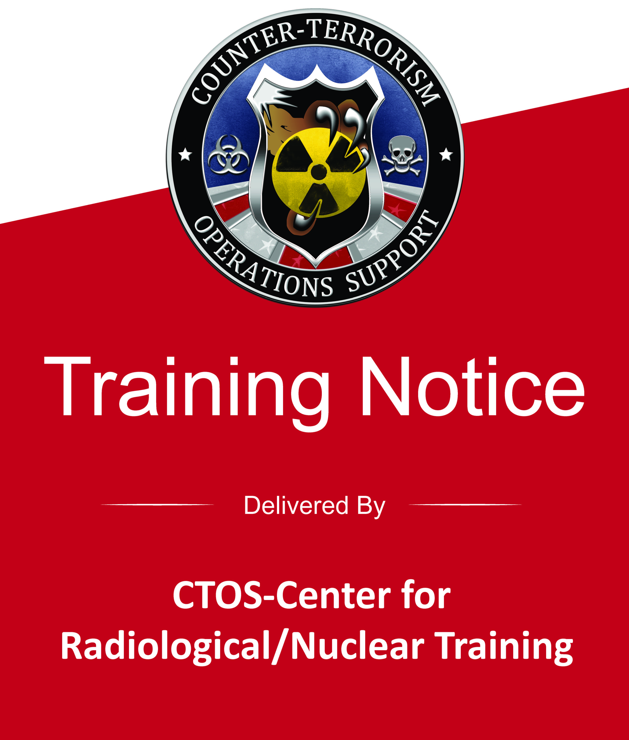 | Population Monitoring at Community Reception Centers Course (PER-332)  Hosted By:  Public Health-Dayton & Montgomery County  Course Location: Madison Lakes Learning and Conference Center ▪ 582 Olive Roads S., Dayton, Ohio 45417  Hours: 0800-1600  Date: Wednesday-April 25, 2018  Course Length: 8 Hours (7 Contact Hours)  Recommended Prerequisites:  AWR-140 or AWR-140-W Introduction to Rad/Nuc WMD Operations
Course Description:
This one-day course prepares emergency responders and non-uniformed support personnel to operate monitoring stations within the Community Reception Center (CRC), or similar reception center, in order to perform population monitoring and contamination reduction measures after a radiological or nuclear incident. (DHS Certification pending.)
SIGN UP - ONLINE
Step 1:  Obtain a FEMA Student Identification (SID) number at https://cdp.dhs.gov/femasid Select “Register for a FEMA SID” and follow the prompts. This number is required to register for all DHS-certified courses. If you already have a number, go to Step 2.  Step 2:  Fill out a CTOS registration form at  http://ctosnnsa.org/pdf/Mobile_Course_Registration_Form.pdf. Ensure each course you desire to attend is identified on the form.  Step 3:  Email your completed registration form to enroll@nv.doe.gov. You will be notified by email regarding completing the prerequisite course. |  | 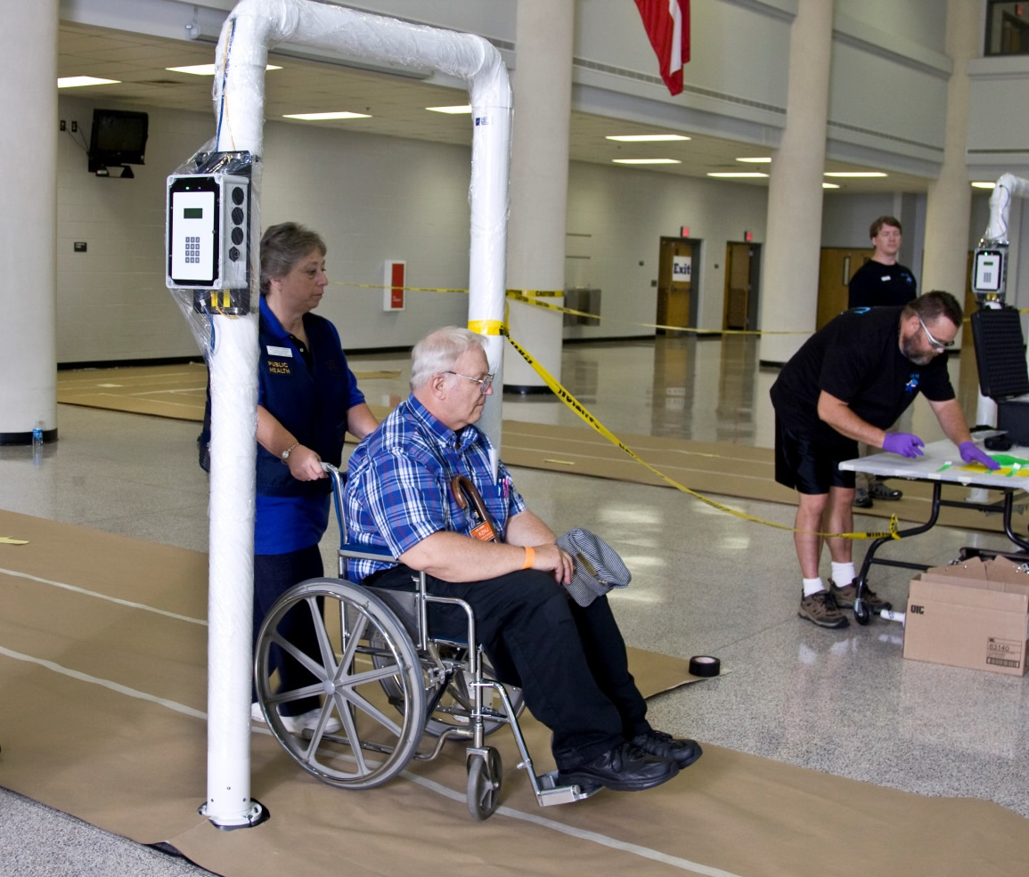  Photo Courtesy: CDC.gov

