
6800 Hoke Road Clayton, Ohio 45315-9740
937-854-6297 Fax 937-837-5619
ae.mvctc.com

SAVE THE DATES

UPCOMING CLASSES AT MVCTC

EMT CLASS
Start date: May 7, 2018
Tuition: $899.00 plus $55.00 for BCI/FBI Background check
Class times: Every Tuesday and Thursday, and every other Monday 1800-2200

ANATOMY AND PHYSIOLOGY COURSE
Start date: June 4, 2018 –July 27, 2018
Tuition: $250.00
Class Times: Hybrid course with most of class completed online. Actual class sessions required on June 6, June 27, and July 18, 2018 from 1800-2100.

Please note this will be the ONLY TIME this course will be offered. This is a pre-requisite for enrollment into the August 2018 Paramedic Program.

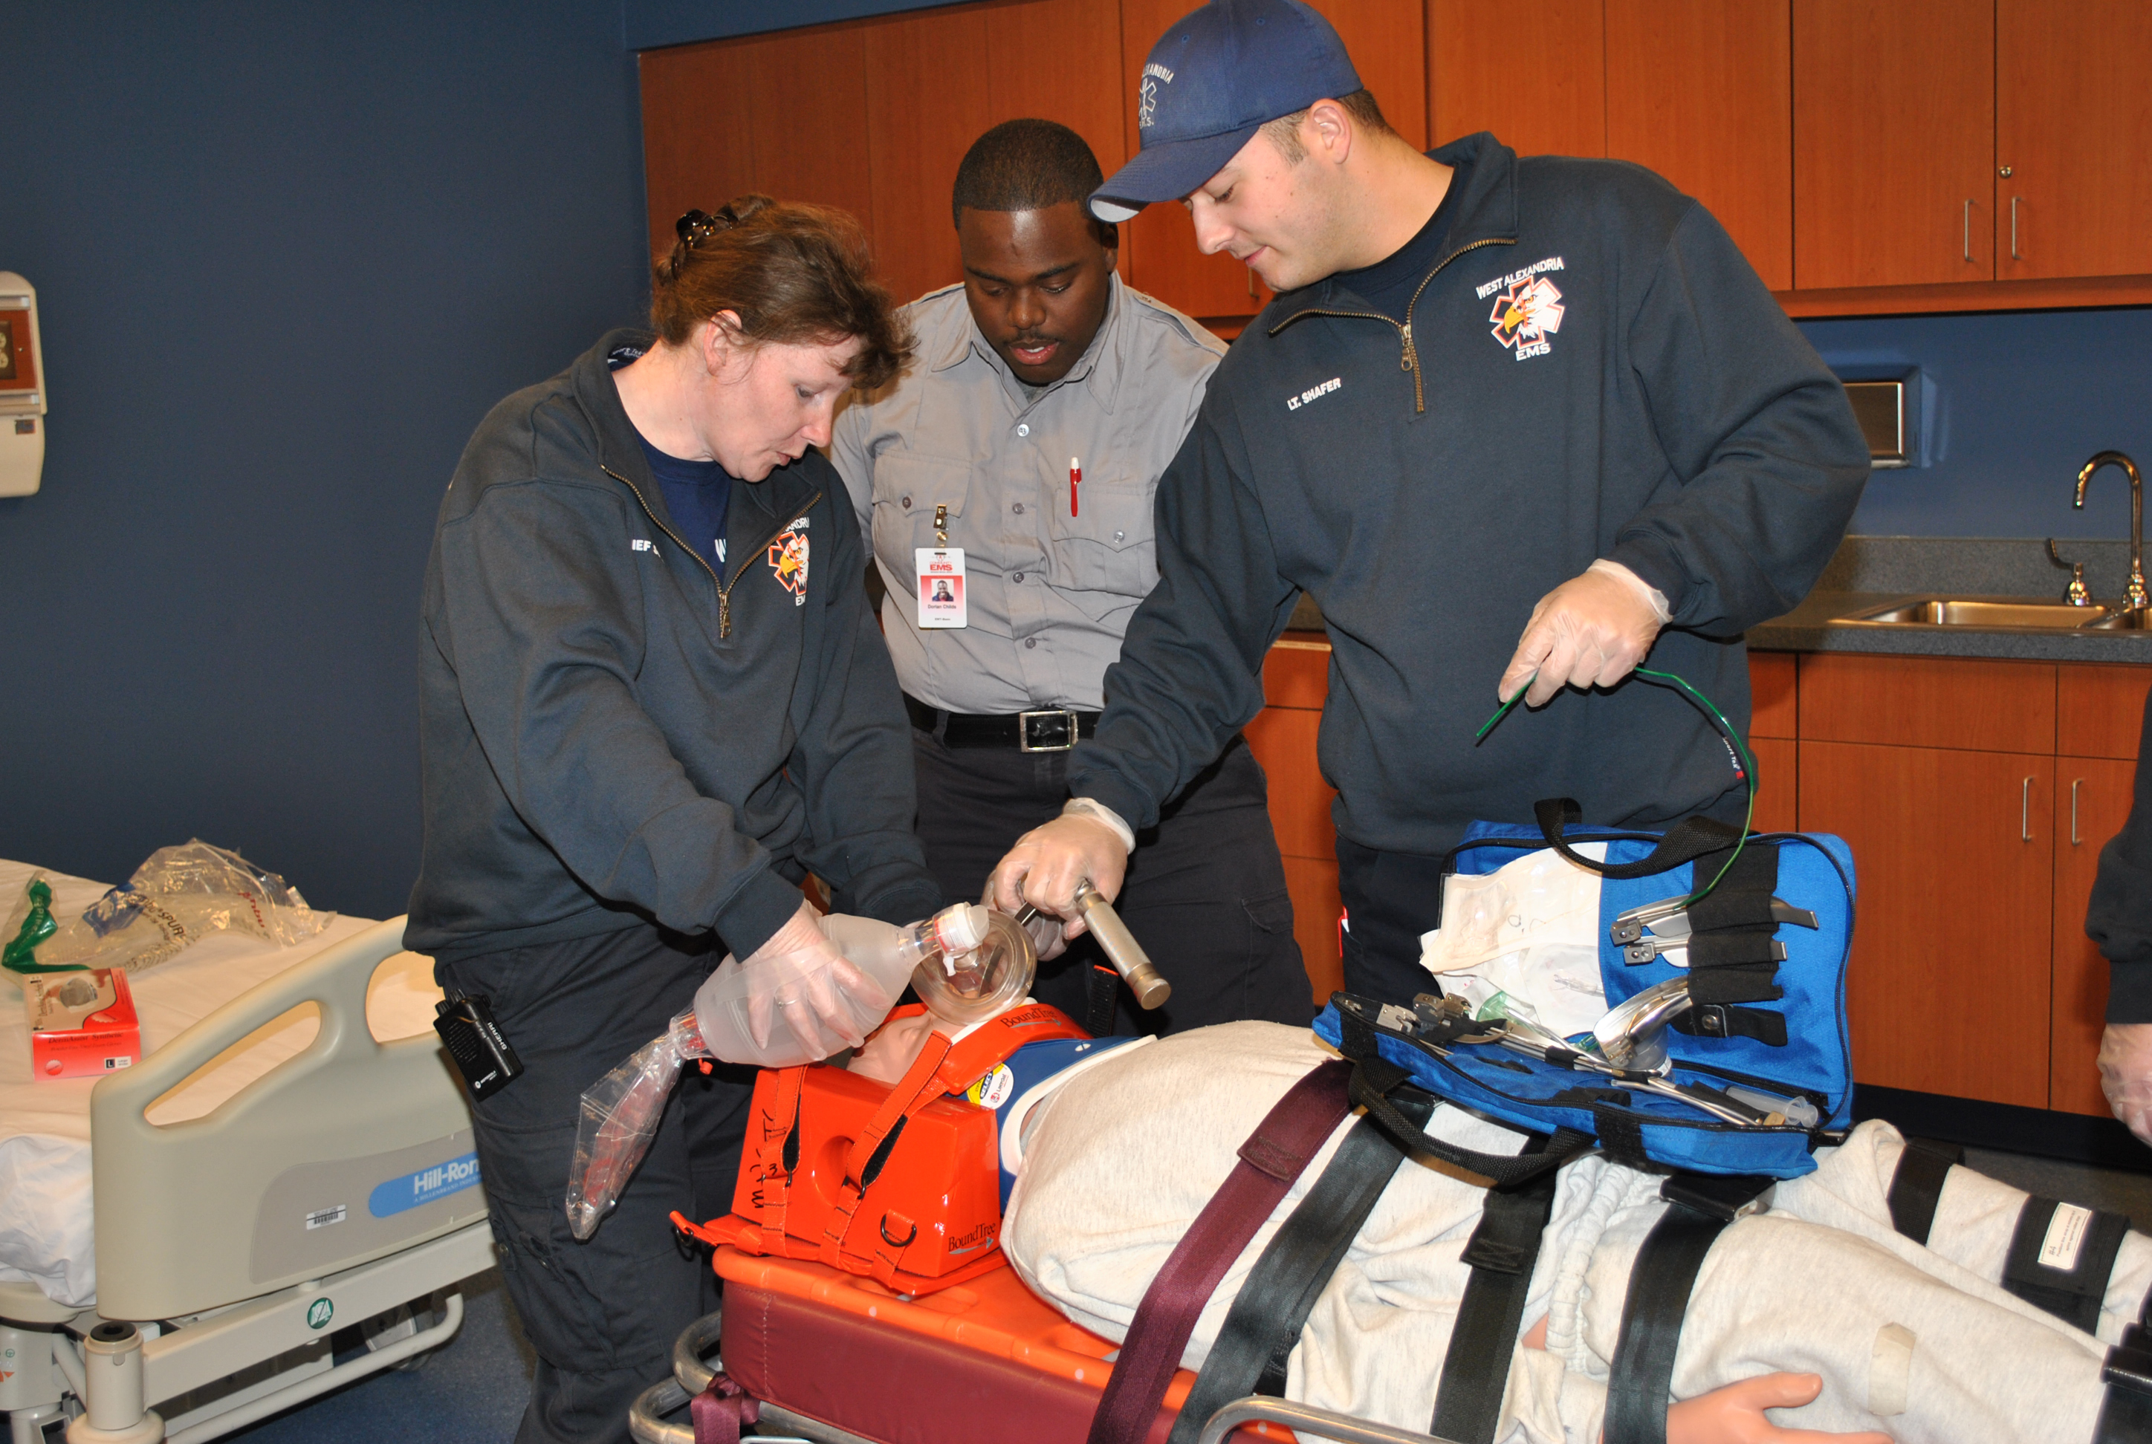

Contact information:
Tony Stringer 937-854-6094
tstringer@mvctc.com

